Project Report - PROPERTY MANAGEMENT APPLICATION USING SALESFORCE

1. INTRODUCTION :

## **Overview A brief description about your project :**

Comparision of Property Management CRM Software

What Property Management CRM Software Should Have

What is salesforce for Property Management

Why Real Estates Companies Use Salesforce for property Management

Benefits of Salesforce CRM for Property Management

Pros & Cons of customizing Salesforce for Property Management Needs

Comparision of Property management Software

Pro & Con of Out –the –box saleeforce –based solutions for property Management

Pro and Cons of Development a Custom property Management app on of Salasforce

Con of Custom Development

Comparison of property Manaagement software

Agent Hub Proper CRM & MLS

## 1.2 Pur pose The use of this project. What can be achieved using :

Property management enables the salaforce for Real Estate companies to keeps a track of crucial date about financial & household properties incorporating associated cash flow primary tenants and occupancy rates

Salesforce property management has powerful tools to remain associated with clients and tenants continuously support futher connections track key date about business and residential properties including occupancy rates essential tenants and revenue and take your productivity ,and business growth to the next level.

Lease Management

Keep track of tenacy contracts

Full inventory administration

Captureand iversee client demandw

Receivables Management

Sales and marketing

EMPATHY MAP ;

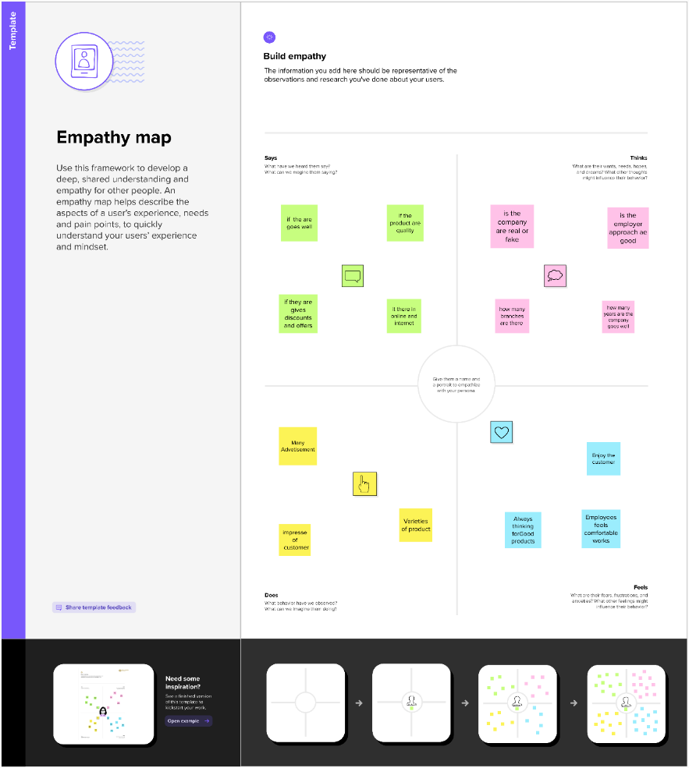

BRAINSTORM :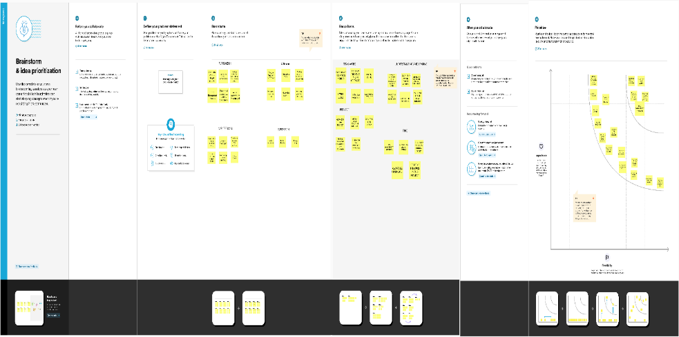

|  |  |
| --- | --- |
| Object Name | Fields in the object |
| Buy | |  |  | | --- | --- | | Field Label | Data Type | | Buy Name | Text(80) | |
| Loan | |  |  | | --- | --- | | Field Label | Data Type | | Loan Name | Text(80) | |

|  |  |  |  |  |  |
| --- | --- | --- | --- | --- | --- |
| Rent | |  |  | | --- | --- | | Field Label | Data Type | | Rent Name | Text(80) | |

Ativity & Screenshot

Rent :

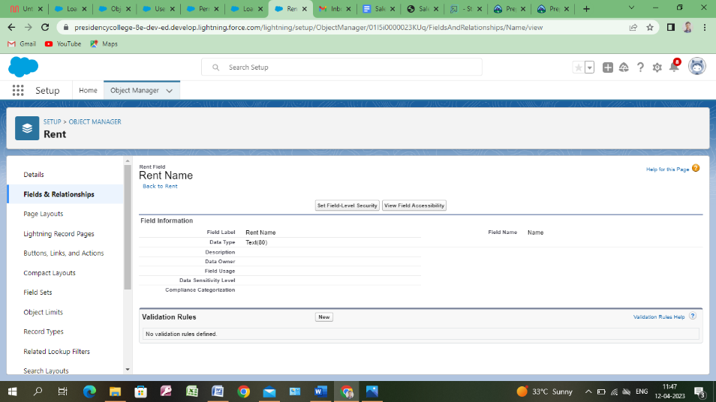

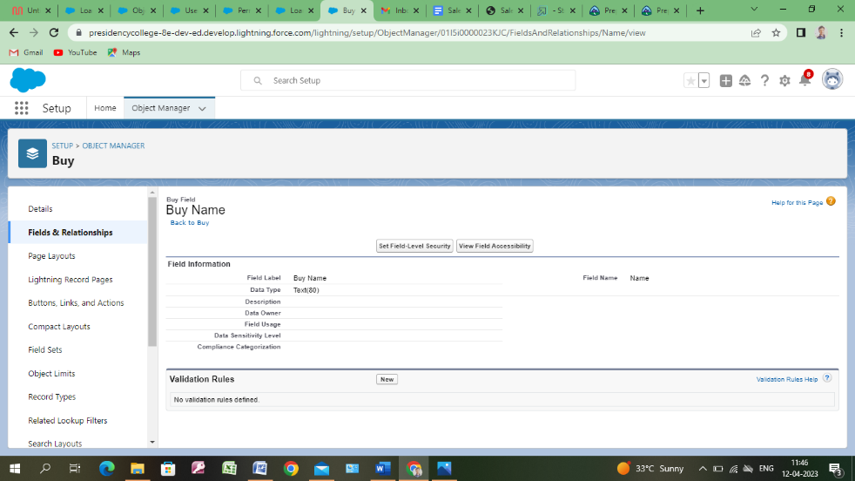Buy : :

Loan :

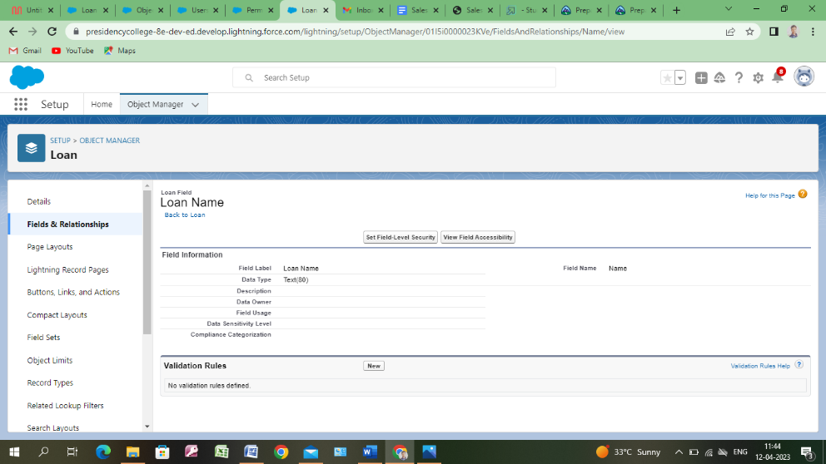

Users :

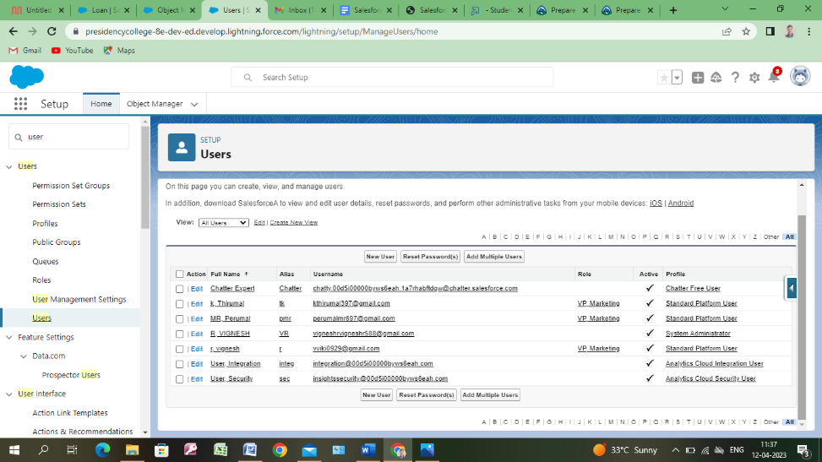

Dashborad :

## 

4. Trailhead Profile Public URL :

Team Lead - <https://trailblazer.me/id/rv126>

Team Member 1 – - https://trailblazer.me/id/thirk11

Team Member 2 –- https://trailblazer.me/id/trailblazerperumal

Team Member 3 –- https://trailblazer.me/id/

5. Advanteges :

Leverage real time reported and dashboards

Streamline led, Opportunity and contact managemeawedwryyk

Simiplify document management and data sharing

Enhance ommunication and collaboratin tools.

# Salesforce helps businesses keepstrack of customer inntractions and sales data .

Disadvanteges:

Lack of specialsts that have a deep understanding of propertymanagement business and its priorities.

Higher price if you loo ot only for technical skills but for industry expertise, especially inn specific niches like property management.

Cluttered interface make navigation and simple tasks unnecessarily complex .

You have to pay for add- ons to get the most out of the software

The learning cure never seems to end .

Application :

 Customer Relationship Management (CRM): Salesforce is widely known for its CRM capabilities, enabling organizations to manage customer interactions, sales processes, and customer data. Salesforce CRM can help businesses track leads, manage customer data, forecast sales, and monitor customer interactions.

Sales Management: Salesforce can also be used to manage sales processes, including pipeline management, opportunity tracking, and forecasting. The platform provides tools for sales reps to manage their leads, track their deals, and monitor their progress.

Marketing Automation: Salesforce offers marketing automation features that enable organition crate and manage marketing campaigns track leads and monitor campaign performaace This can help businesses automate repetitivetaasks nd improve the effiienc yof their marketing efforts.

Conclusion :

In conclusion, the property management application developed using Salesforce has shown great potential in improving the efficiency and effectiveness of property management processes. Through the integration of various features such as automated workflows, real-time data analytics, and streamlined communication channels, the application has been able to provide property managers with a comprehensive solution to their needs. The findings of this project demonstrate that the application has the potential to reduce the time and costs associated with managing properties, while also providing a higher level of customer service to tenants.

Customization: Salesforce offers a wide range of customization options that can be used to create a tailor-made property management application. This includes the ability to create custom objects, fields, and workflows that match the specific needs of the property management industry.

Automation: Salesforce has powerful automation tools that can be used to automate routine tasks such as scheduling appointments, sending reminders, and generating reports. This can help property managers save time and increase their efficiency.

Integration: Salesforce can be integrated with other applications such as accounting software, property management software, and marketing automation tools. This can help property managers streamline their workflows and improve their overall operations

Mobile: Salesforce offers a mobile application that can be used by property managers to access important information on-the-go. This can include property listings, tenant information, maintenance requests, and more.